**Marjory Stoneman Douglas High School**

**School Advisory Council**

**Minutes**

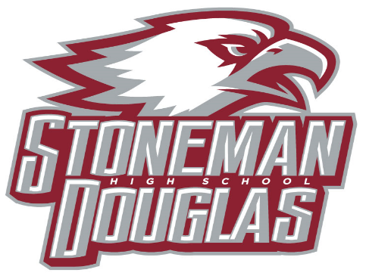

**DATE:** Wednesday, May 12, 2021

**TIME:** 3:15 PM

**LOCATION:** Media Center/TEAMS

1. **Welcome/Call to Order/Review of Agenda**
2. **Attendance (Roll Call)**
3. **Principal’s Report – Mrs. Kefford presented the following**
4. School enrollment projection for the 2021-2022 school year is 3,304 students
5. Budget projection process for the 2021-2022 school year, however the budget is not final until October 2021 after the FTE count.
6. SIP Goals for the 2020-2021 school year were reviewed.
7. What are school accountability funds? Florida Statute indicates that accountability funds shall be used to “develop and implement” the School Improvement Plan. Schools are funded $5.00 per student based on the prior year enrollment.
8. Additional projected allocations such as instructional allocations, support allocations, categorical allocations and special revenue funding were explained.
9. Testing update – 9th and 10th grade FSA ELA testing is complete. Currently testing, EOCs. Senior final exams 5/25-5/28 and underclass final exams 6/4-6/9.
10. Summer school update – summer school will be held at Westglades Middle School.
11. Professional Study Days (PSD) have been approved for the 2021-2022 school year for MSD- September 2, 2021; October 7, 2021; November 4, 2021; December 2, 2021; January 6, 2022; February 3, 2022; March 3, 2022; April 7, 2022.
12. The 2021 Graduation Ceremony will take place on Tuesday, June 8 at 7:00 PM at the BB&T Center.
13. **Revision/Approval of March and April 2021 SAC Minutes**

Motion to approve minutes for March and April meetings by Robert Mayersohn, second by Melissa Falkowski, motion approved.

1. **Officers’ Reports**
2. **School Improvement Plan (SIP)**
3. Election of Officers – slate of SAC Officer nominees for the 2021-2022 school year was presented by Debra Wanamaker, Jacob Abraham, and Kim Johnson. Nominees for SAC Co-Chairs, Holly Van Tassel-Schuster and Elisa Williamson; SAC Secretary, Carla Verba. Calls for nominations from the floor resulted in none. Motion to close the nominations by Robert Mayersohn, second by Stefanie Tephford, motion approved.

Motion to elect Holly Van Tassel-Schuster and Elisa Williamson as SAC Co-Chairs and Carla Verba as SAC Secretary for the 2021-2022 school year by Robert Mayersohn, second by Jacob Abraham, motion approved.

1. **School-wide Positive Behavior Plan (SPBPP) monitoring/moved to next year**- committee will convene during the 2021-2022 school year
2. **Accreditation Process** – Not up for accreditation this year
3. **SAC Accountability Funds** currently: $67,708 ($43,700 available) - The following requests were made for funds
4. Patti Thompson and Andrea Kowalski-Rospierski requested $3,600 to purchase J-Stor, a database that stores reliable scholarly journals that will be accessible to all students and teachers. The journals can be used for research and to assist in writing for the FSA. Motion to approve by Stefanie Tephford, second by Robert Mayersohn, motion approved
5. Melissa Falkowski requested $1200 to purchase an SRA Reading Box to be used with students who have not met concordant reading scores. Motion to approve by Stefanie Tephford, second by Robert Mayersohn, motion approved.
6. Diana Haneski requested $1200 to purchase books for the Florida Teens Reads program. The program provides high-interest novels to help students find a love for reading and can improve FSA reading scores. Motion to approve by Stefanie Tephford, second by Robert Mayersohn, motion approved.
7. **SAF report** - given by Elisha Johnson, SAF chair
8. **Special orders/unfinished business from previous meeting** – there was no unfinished business
9. **New Business** – none
10. **Announcements/Reminders** – Professional Study Days have been cancelled for the rest of the school year.
11. **Next Meeting** – September 2021 at 3:15 in the media center (day will be given at the beginning of the 2021-2022 school year)
12. **Adjournment** at 3:56 PM